|  |
| --- |
| Home tank automation |

**A Product for rest of us**

|  |
| --- |
|  |
| **Aurangzaib ( EE-120 )** – Lead designer and Programmer  **Furqan ( EE-122 )** – layout creator and Programmer |
| **Aamir ( EE-139 )** – Layout creator |
| **Ahmed ( EE-84 )** – Parts Manager |

**A Product by:**

**pns Research Center**

**Introduction**

|  |
| --- |
| Automate is the product designed from scratch to fully automate the upper and lower tank monitoring and controlling. Highly modular architecture and highly tested |

**Description**

Technical details:

|  |
| --- |
| Lcd – to show the data received from controller, to show status of operation  Power supply – to provide dc source to the circuit  Relay – to control the loads  Control buttons – to disable the system and to reset the circuit  Microcontroller – Atmel, ATMega16 – to process the whole operation |

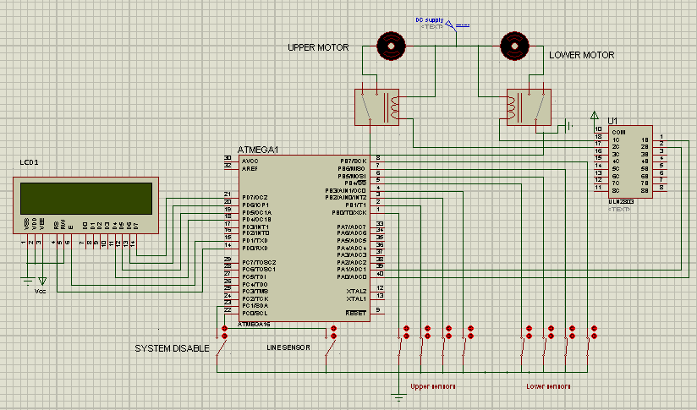

Operational details:

|  |
| --- |
| It starts working from checking the disable switch, if its pressed, the system will be paused and no operation will be performed.  If disable switch is not pressed, then, it starts from checking the upper tank for level of water, if level is sufficient, then it wont run the motor. Otherwise it will then check the lower tank and if lower tank has sufficient water then upper motor will be started until upper tank get filled or the lower tank get empty.  If lower tank is empty, then it will check the line, if water supply is active in line then lower motor will be started  This whole operation keeps running and the status will be shown on the LCD panel. |